**NAME: PARTH NITESHKUMAR PATEL**

**ID: 19DCS098**

**CLASS: CSE 2**

**SUBJECT: JAVA**

**WEEK-4**

**1. Write an application that demonstrates a class inheritance hierarchy. Class M extends object and has two instance variables of type float and String. Class N extends M and has one instance variable of type Double. Instantiate class N. Initialize and display its variables.**

**CODE:**

class Object

{

Object()

{

System.out.println("This is object class constructor");

}

}

class M extends Object

{

float x;

String str;

M()

{

System.out.println("This is class M constructor");

}

}

class N extends M

{

double y;

N(float x,String str,double y)

{

System.out.println("This is class N constructor");

this.x=x;

this.str=str;

this.y=y;

}

void display()

{

System.out.println(x+"\n"+str+"\n"+y);

System.out.println("PARTH PATEL\n19DCS098");

}

}

class SP_16

{

public static void main(String[] args)

{

N n=new N(2.22f,"HELLO",3.9886);

n.display();

}

}

**OUTPUT:**

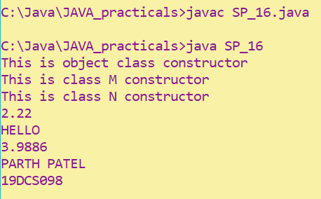

**2. Create a class named 'Member' having the following members:**

**Data members**

1. **- Name**
2. **- Age**
3. **- Phone number**
4. **- Address**
5. **– Salary**

**It also has a method named 'printSalary' which prints the salary of the members. Two classes 'Employee' and 'Manager' inherits the 'Member' class. The 'Employee' and 'Manager' classes have data members 'specialization' and 'department' respectively. Now, assign name, age, phone number, address and salary to an employee and a manager by making an object of both of these classes and print the same.**

**CODE:**

class Member

{

String Name,ph_number,Add;

int age,salary;

void printSalary()

{

System.out.println("Salary : "+salary);

}

}

class Employee extends Member

{

String dep;

String spec;

Employee(String Name,int age,String ph_number,String Add,String dep,String spec,int salary)

{

this.Name=Name;

this.age=age;

this.ph_number=ph_number;

this.Add=Add;

this.dep=dep;

this.spec=spec;

this.salary=salary;

}

void display()

{

System.out.println("Name: "+Name);

System.out.println("Age :"+age);

System.out.println("Phone Number : "+ph_number);

System.out.println("Address : "+Add);

System.out.println("Specialization : "+spec);

printSalary();

}

}

class Manager extends Member

{

String dep;

String spec;

Manager(String Name,int age,String ph_number,String Add,String dep,String spec,int salary)

{

this.Name=Name;

this.age=age;

this.ph_number=ph_number;

this.Add=Add;

this.dep=dep;

this.spec=spec;

this.salary=salary;

}

void display()

{

System.out.println("Name: "+Name);

System.out.println("Age :"+age);

System.out.println("Phone Number : "+ph_number);

System.out.println("Address : "+Add);

System.out.println("Specialization : "+spec);

printSalary();

}

}

class SP_17

{

public static void main(String[] args)

{

Employee e1=new Employee("PNP",24,"88888","IND","DEvops","M.tech",10000);

Manager m1=new Manager("MNP",30,"66666","IND","ACC","MBA",30000);

e1.display();

System.out.println();

m1.display();

System.out.println("PARTH PATEL\n19DCS098");

}

}

**OUTPUT:**

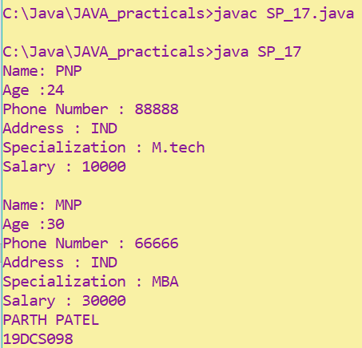

**3. Create a class named 'Rectangle' with two data members 'length' and 'breadth' and two methods to print the area and perimeter of the rectangle respectively. Its constructor having parameters for length and breadth is used to initialize length and breadth of the rectangle. Let class 'Square' inherit the 'Rectangle' class with its constructor having a parameter for its side (suppose s) calling the constructor of its parent class as 'super(s,s)'. Print the area and perimeter of a rectangle and a square.**

**Also use array of objects.**

**CODE:**

class Rectangle

{

double l,b;

Rectangle(double l, double b)

{

this.l = l;

this.b = b;

}

double Perimeter()

{

return 2*(l+b);

}

double Area()

{ return l*b;

}

}

class Square extends Rectangle

{

Square(double length, double breadth)

{

super(length,breadth);

}

}

class SP_18

{

public static void main(String arg[])

{

Square s1[] = new Square[2];

s1[0] = new Square(10,12.5);

s1[1] = new Square(5,15);

System.out.println("Perimeter of Rectangle : "+s1[0].Perimeter());

System.out.println("Area of Rectangle :"+s1[0].Area());

System.out.println("Perimeter of Rectangle : "+s1[1].Perimeter());

System.out.println("Area of Rectangle is:"+s1[1].Area());

System.out.println("PARTH PATEL\n19DCS098");

}

}

**OUTPUT:**

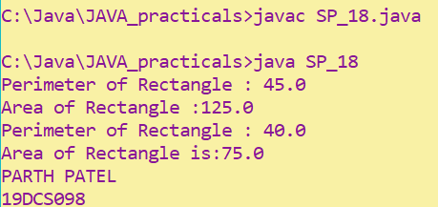

**4. Create a class named 'Shape' with a method to print "This is This is shape". Then create two other classes named 'Rectangle', 'Circle' inheriting the Shape class, both having a method to print "This is rectangular shape" and "This is circular shape" respectively. Create a subclass 'Square' of 'Rectangle' having a method to print "Square is a rectangle". Now call the method of 'Shape' and 'Rectangle' class by the object of 'Square' class.**

**CODE:**

class Shape

{

void printShape()

{

System.out.println("This is Shape");

}

}

class Rectangle extends Shape

{

void printRectangle()

{

System.out.println("This is Rectangle");

}

}

class Circle extends Shape

{

void printCircle()

{

System.out.println("This is Circle");

}

}

class Square extends Rectangle

{

void printSquare()

{

System.out.println("Square is a Rectangle");

}

}

class SP_19

{

public static void main(String args[])

{

Square s=new Square();

s.printShape();

s.printRectangle();

System.out.println("PARTH PATEL\n19DCS098");

}

}

**OUTPUT:**

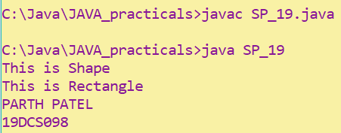

**5. Write a java that implements an interface AdvancedArithmetic which contains a method signature int divisor_sum(int n). You need to write a class called MyCalculator which implements the interface. divisorSum function just takes an integer as input and return the sum of all its divisors. For example divisors of 6 are 1, 2, 3 and 6, so divisor_sum should return 12. The value of n will be at most 1000.**

**CODE:**

import java.util.*;

interface AdvancedArithemetic

{

int divisor_sum(int n);

}

class MyCalculator implements AdvancedArithemetic

{

public int divisor_sum(int n)

{ int sum=0;

for(int i=1;i<=n;i++)

{

if(n%i==0)

sum+=i;

}

return sum;

}

}

class SP_20

{

public static void main(String arg[])

{

Scanner input = new Scanner(System.in);

System.out.print("Enter Number : ");

int num = input.nextInt();

while(num>1000)

{

System.out.print("Enter the value of num : ");

num = input.nextInt();

}

AdvancedArithemetic c1 = new MyCalculator();

System.out.println("Answer : "+c1.divisor_sum(num));

System.out.println("PARTH PATEL\n19DCS098");

}

}

**OUTPUT:**

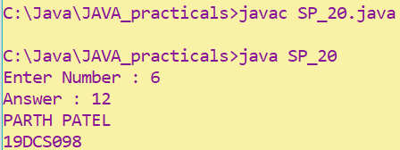

**6. Assume you want to capture shapes, which can be either circles (with a radius and a color) or rectangles (with a length, width, and color). You also want to be able to create signs (to post in the campus center, for example), each of which has a shape (for the background of the sign) and the text (a String) to put on the sign.**

**Create classes and interfaces for circles, rectangles, shapes, and signs.**

**Write a program that illustrates the significance of interface default method.**

**CODE:**

interface Sign

{

void text(String s);

}

class Shape

{

void display()

{

System.out.println("This is shape");

}

}

interface C extends Sign

{

default void print()

{

System.out.println("This is Circle");

}

}

class Circle extends Shape implements C , Sign

{

int radius = 20;

String color = "Red";

void display()

{

super.display();

System.out.println("Radius of circle: "+radius+" and Color: "+color);

}

public void text(String s)

{

if(s.equals("Left") || s.equals("left") || s.equals("LEFT") )

{

System.out.println("Point towards: Left");

System.out.println("Message: "+s);

}

else if(s.equals("Right") || s.equals("right") || s.equals("RIGHT") )

{

System.out.println("Point towards: Right");

System.out.println("Message: "+s);

} else { System.out.println("Point towards: Center");

System.out.println("Message: "+s);

}

}

} interface R

{

default void print()

{

System.out.println("This is Rectangle");

}

}

class Rectangle extends Shape implements R , Sign

{

int length = 10 , width = 15; String color = "White"; void display()

{

super.display();

System.out.println("Length of Rectangle: "+length+" and Width: "+width+" with Color: "+color);

}

public void text(String s)

{

if(s.equals("Left") || s.equals("left") || s.equals("LEFT") )

{

System.out.println("Point towards: Left");

System.out.println("Message: "+s);

}

else if(s.equals("Right") || s.equals("right") || s.equals("RIGHT") )

{

System.out.println("Point towards: Right");

System.out.println("Message: "+s);

} else

{

System.out.println("Point towards: Center");

System.out.println("Message: "+s);

}

}

}

class SP_21

{

public static void main(String args[])

{

Circle c = new Circle();

c.display();

c.text("Center");

Rectangle r1 = new Rectangle();

r1.display();

r1.text("Right");

System.out.println("PARTH PATEL\n19DCS098");

}

}

**OUTPUT:**

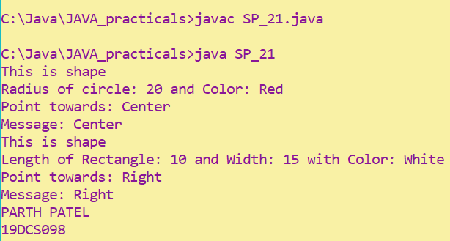

**7. Write a java program which shows importing of classes from other user define packages.**

**CODE:**

package pack_1;

public class pack_prac_1

{

public void show()

{

System.out.println(" This is Package");

}

}

import pack_1.*;

class SP_21

{

public static void main(String[] args)

{

pack_prac_1 p1 = new pack_prac_1();

p1.show();

}

}

**OUTPUT:**

